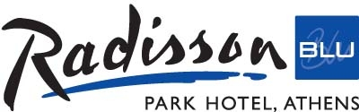

ACCOMMODATION FORM ISCO MEETING APRIL 2012

Please complete and return to hotel no later than 1ST April 2012 and send by

Fax +302108238420 or e mail anna.agrafa@rbathenspark.com

NAME______ ________________________________________
Telephone___________________________
Fax or e mail__________________________

DATES OF STAY:

Arrival________

Departure____________

Standard deluxe Room
Single occupancy _______ € 80,00
Double occupancy _______ € 100,00

Superior deluxe Room
Single occupancy _______ € 100.00
Double occuapancy _______ € 120.00

Rates are per day & include:
Buffet breakfast
Wi Fi Internet
Use of the fitness center
All taxes

In order to guarantee reservation, please fill in your credit card details.

Name of card holder:
__________________________________________________________________________

Credit card nr & CVV nr ____________________

Expiration date ________________________________

Credit card will be charged a one night cancellation fee incase of cancellation as of April 14th 2012 or in case of non show.

I agree with above terms.
Signature ____ ________________________

Radisson Blu Park Hotel Athens- 10 Alexandras Ave. - 106 82 Athens- Greece
Tel. 210- 88 94 506, Fax: 210- 82 38 420
: www.rbathenspark.com, E-mail anna.agrafa@rbathenspark.com

