L'authentification
est-elle garantie
dans un réseau mobile
ad hoc ?
Tintin!

D. de Werra

EPFL

T. Jaccard, NESTEC
D. Schindl, EPFL

Self-organized Public-Key Management
for mobile Ad Hoc Networks

High level of self-organization
no central authority
Goal: define mechanism for securing
networking functions (e.g. routing)
and application services in
mobile ad hoc networks.
Public-key based security system:

¿ how to make the public-key of each user available to others so that its authenticity can be verified ?
Use of Public-key Certificates
public-key cryptography scheme
to support security services in the network

Problem: how can a user v obtain the authentic public-key of another user w in presence of an “active attacker” ?

Self organized system
(Capkun, Buttyan, Hubaux, LCA EPFL)

- users generate their keys and issue certificates
- no central certification authority
- no certification directories
- no special role assigned to a subset of nodes
- no preinstalled keys or procedures

If user v believes that a given public-key belongs to user w, then v issues a public-key certificate (PKC) to w
Certificate graph: G = (V, U)
V : set of keys
arc (v, w) ε U ↔
v issued a
PKC to w

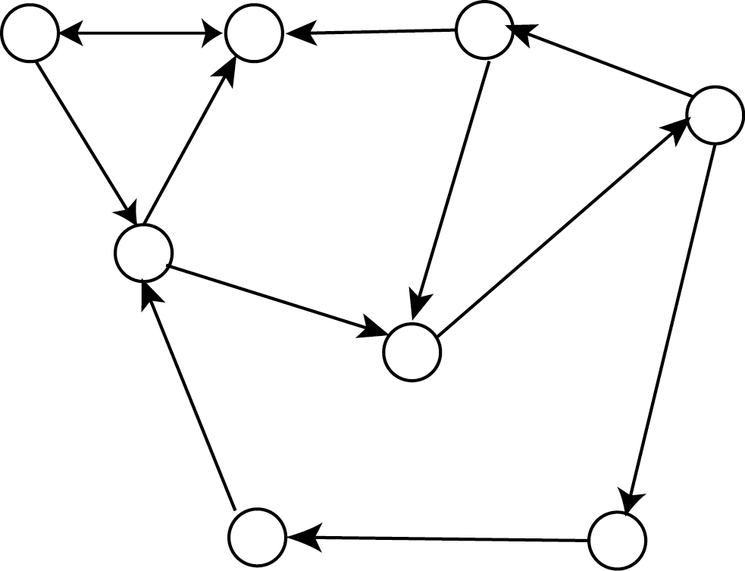

authentification occurs
via paths of certificates

system (Capkun, Buttyan, Hubaux)
- certificates stored and distributed by users
- each user maintains a local certificate repository
(with a limited number of certificates selected by user).

v wants to verify authenticity of public-key of w:
v and w merge local repositories and v tries to
find a path of certificates from v to w.

- keep directories small
- create certificate paths for possibly
all pairs of users
● ● ●
graph model for repositories
Model: certificate graph G = (V, U)
nodes = keys K_{v} (associated to user v)
arcs = certificates
(K_{v}, K_{w}) ε U ↔ ∃ certificate signed with
private key of v
which identifies K_{w}
Each v stores a partial graph G_{v} of G
(containing node K_{v}).
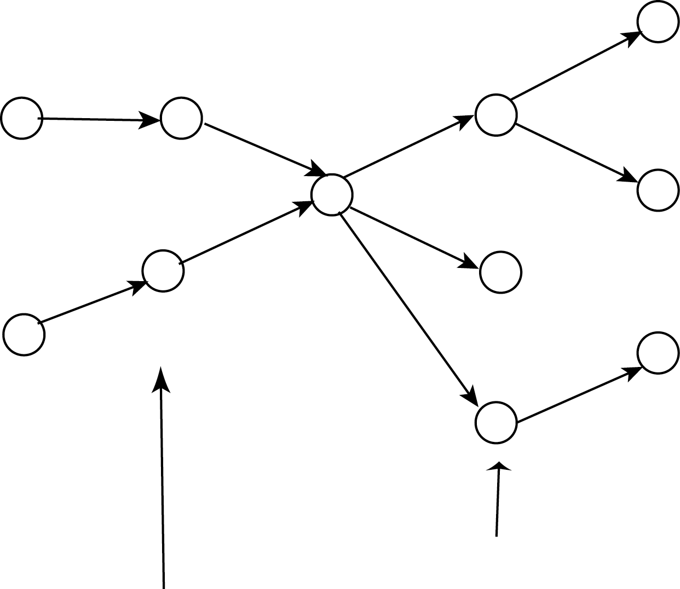
certificate issued by v
certificates issued by others to w
additional
certificates
K_{v}
Hyp: users take same algorithm to build their
repositories
certificate graph G strongly connected
Problem: G = (V, U) strongly connected.
Associate to each node v ε V a partial
subgraph G_{v} = (V_{v}, U_{v}) so that:

(scalability) size of local repositories is
kept “small”
(performance) for all pairs G_{v}, G_{w}
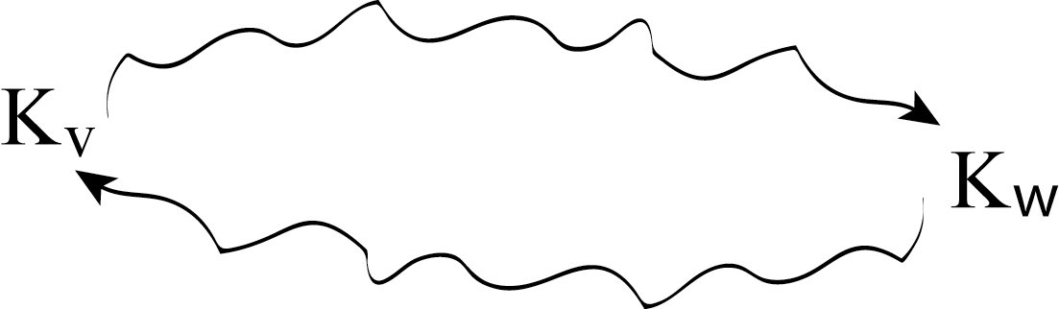
G_{v} G_{w}

(robustness) all certificates used for
authentification almost same
number of times

(invariance to certificate graph changes)
Notations
solution F = {G_{v} | v ε V} for G = (V, U)
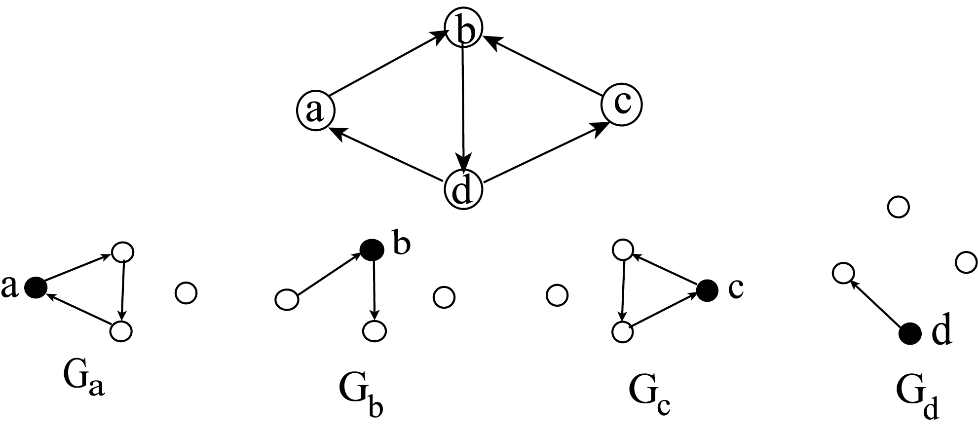
s_{F,G} (v) = size of repository of v = |U_{v}|
s_{F,G} (a) = 3 s_{F,G} (b) = 2
s_{F,G} (c) = 3 s_{F,G} (d) = 1
s_{F,G} = max {s_{F,G} (v) | v ε V}
Here: s(F,G) = 3
u_{F,G} (v) = use of a public-key (node)
= | { w ε V : v ε V (G_{w}) }|
u_{F,G}(a) = 3 u_{F,G}(b) = 3 u_{F,G}(c) = 1 u_{F,G}(d) = 4
u_{F,G} = max = { u_{F,G}(v) | v ε V } = 4 here!
Basic performance of solution F for G
⇝
# pairs v, w with v w in G_{v} U G_{w}
p (F,G) =
⇝
# pairs v, w with v w in G

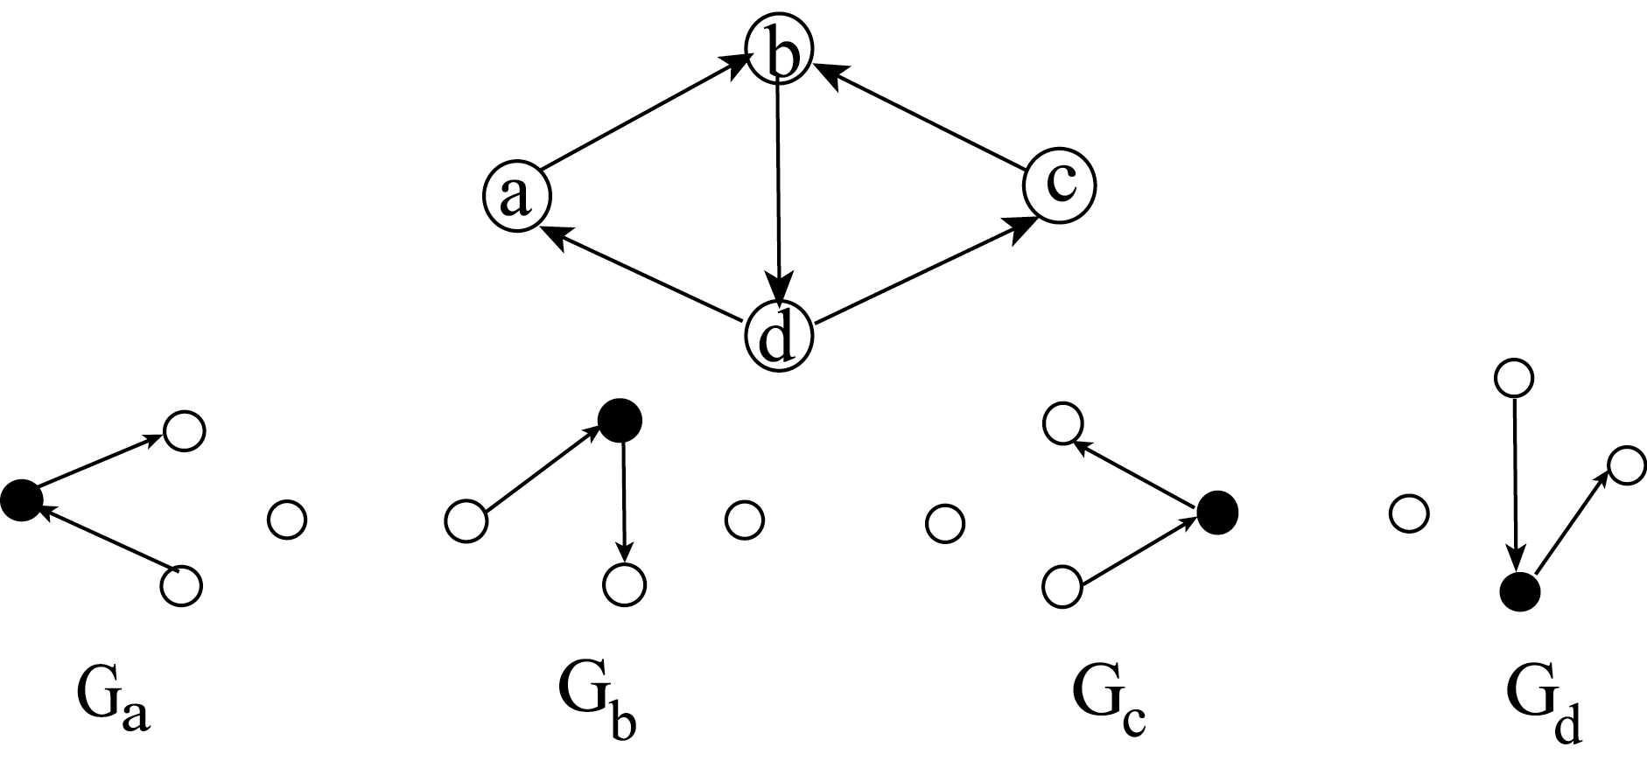
ab ad
ba bc bd
cb cd da
dc
p(F,G) = $\frac{9}{\text{12}} = \frac{3}{4}$ db ac ca
s(F,G) = 2
Typical | min s(F,G)
problem | s.c. p(F,G) ≥ p_{o}
 | u(F,G) ≤ u_{o}
Basic problem:

G = (V,U) strongly connected; integer k
¿ ∃ U_{v} ⊆ U | U_{v} | ≤ k ∀ v ε V
such that ∀ v, w
U_{v} U_{w} contains a path from v to w
and a path from w to v
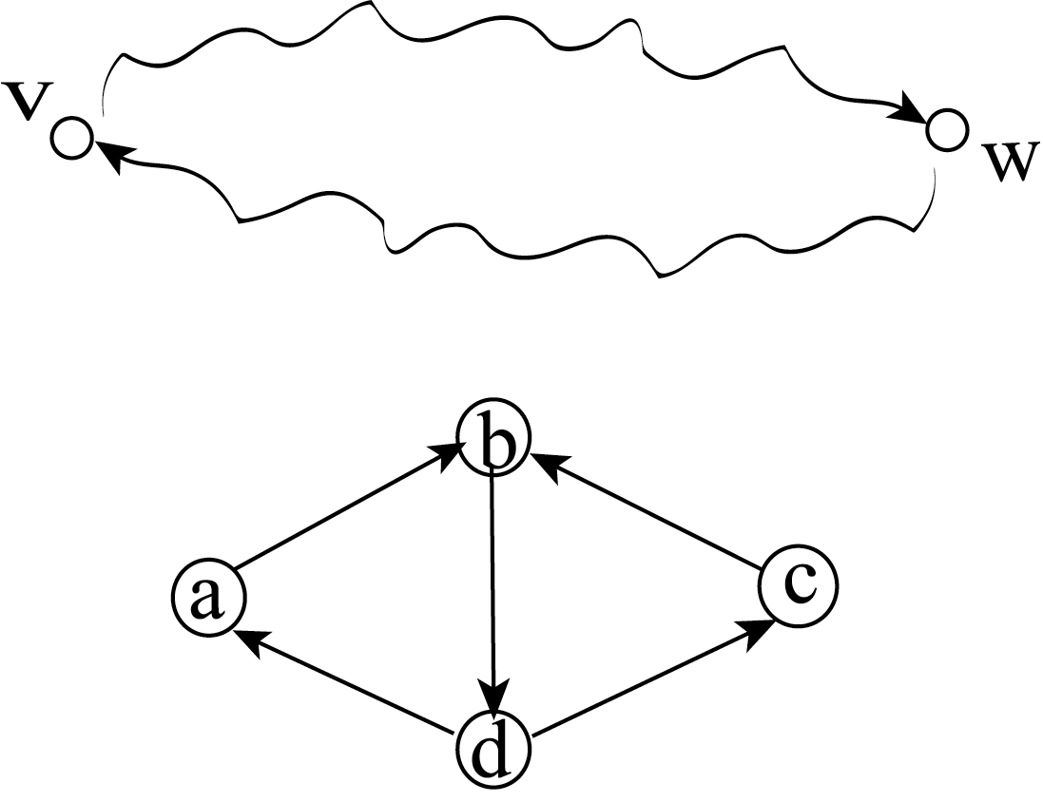
complexity ?
U_{v} U_{w}
For ac and ca: 5 arcs needed
→ no solution F with k = 2 = s(F,G)
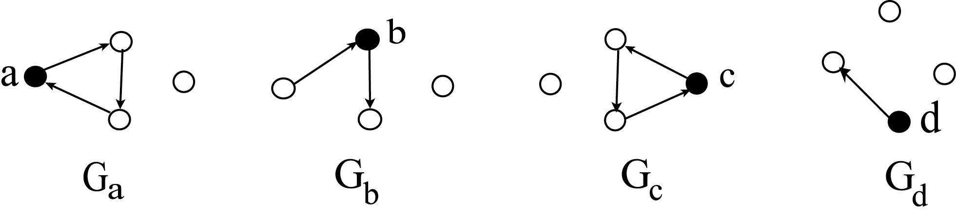
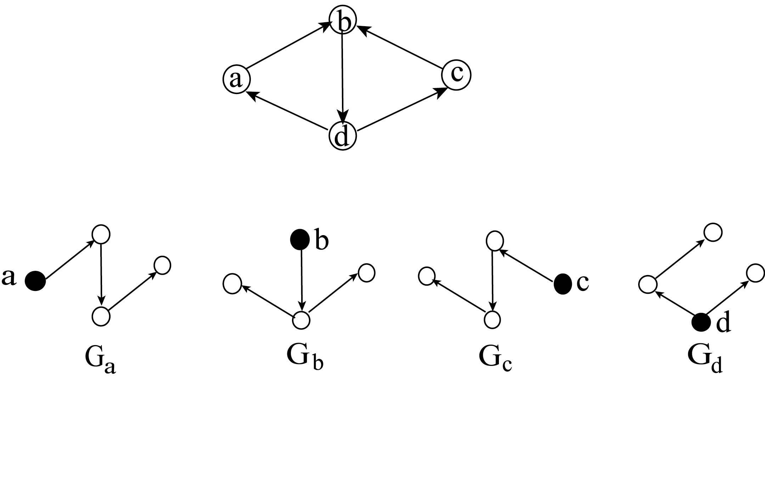
s(F,G) = 3
All G_{v} are out-trees of v

Consider G_{v} which are
(out-tree of v) (in-tree of v)

Notation: d(v,w) = length of shortest
path from v to w
(# of arcs)
Bounds on
s_{opt}(G) = min s(F,G)
F
Find x center of G: such that

max (d(x,v) + d(v,x)) = min !
v ε V

Let sp(v,w) = shortest path from v to w
U_{v} = sp(v,x) sp(x,v) v ε V

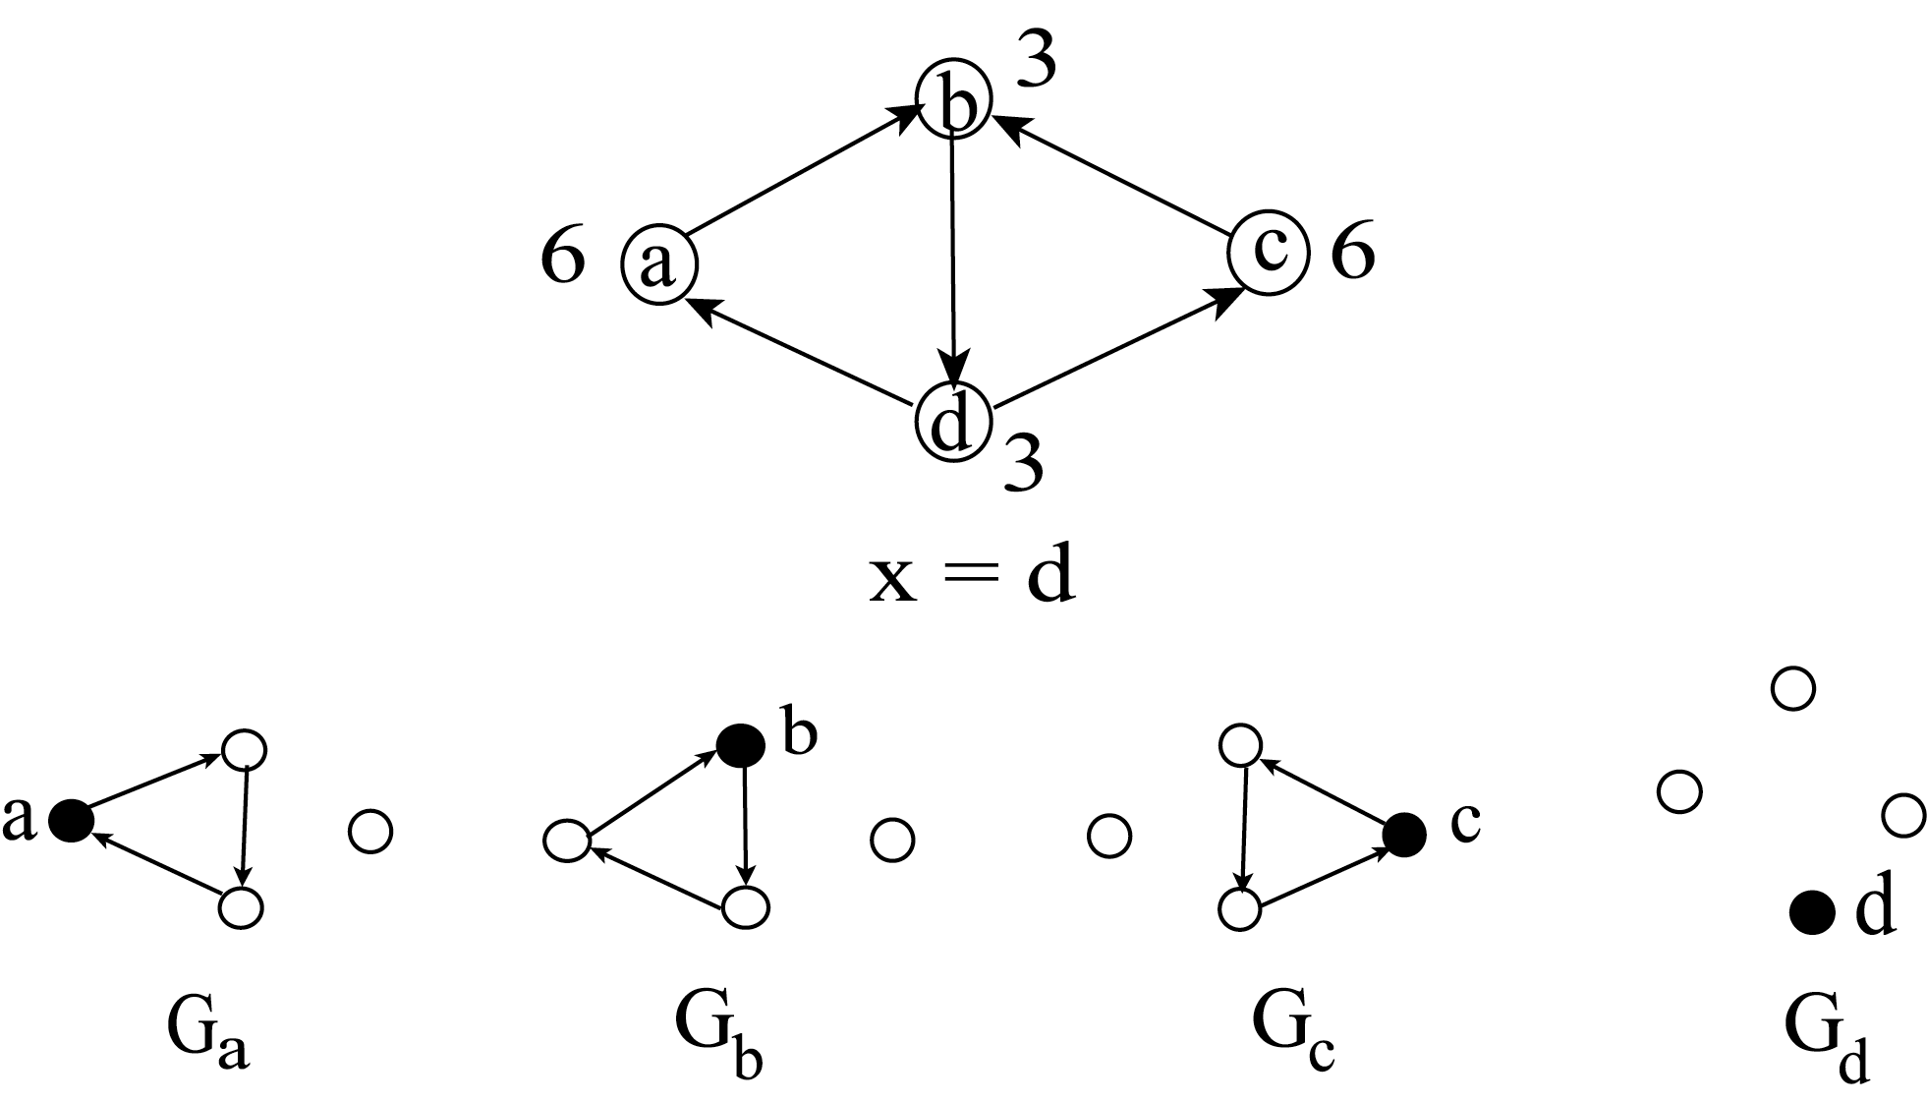

s_{a}(F,G) = 3 s_{b}(F,G) = 3 s_{c}(F,G) = 3 s_{d}(F,G) = 0

s_{opt}(G) ≤ min max(d(x,v) + d(v,x))
x ε V v ε V

In example: s_{opt}(G) ≤ 3

ALG01: Find a center x
Set G_{v} = sp(v,x) sp(x,v) ∀ v ε V

→ bound on s_{opt}(G)

→ performance p(F,G) = 1

NB: Bound not sharp for circuit C_{k}
on nodes 1,2,…,k
for all v: (d(v,x) + d(x,v)) = k

But ∃ solution with G_{v} = C_{k} – (v-1,v)
s_{F,G}(v) = k – 1 for all v
s(F,G) = k – 1
p(F,G) = 1

NB: min max (d(x,v) + d(v,x)) – s_{opt}(G)
x ε V v ε V
can be large !
Bound = min {6k + 2, 6k, ..., 4k + 4,...,4k,...,6k + 2}
↑ ↑
1 → 3k + 2 1 → k + 1
1 → 3k + 1
= 4k
But ∃ solution F with s(F,G) = $\left| U_{3k+2} \right|$ = 2k + 2
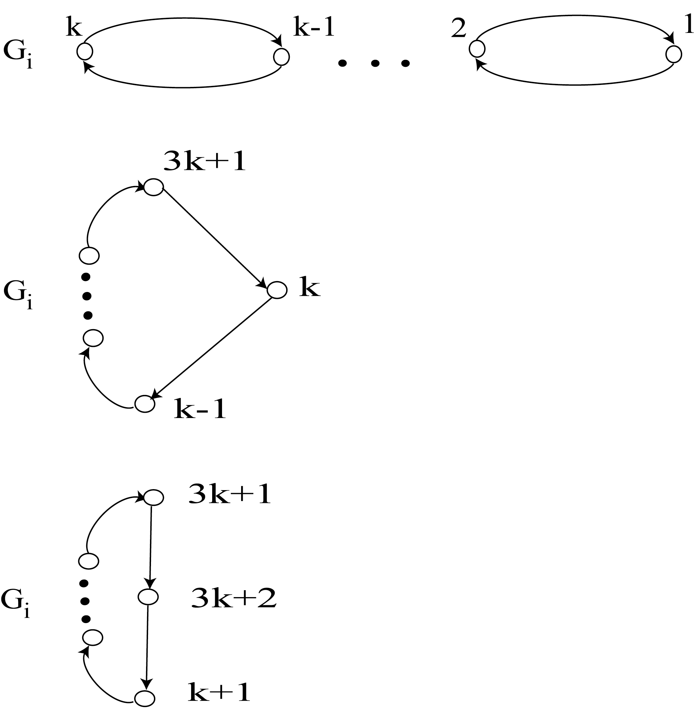
$$1 ≤ i ≤ k$$
$$k + 1 ≤ i ≤ 3 k + 1$$
i = 3k + 2

s(F,G) ≥ $\frac{1}{4}$ max max {d(x,y) + d(y,x)}
x ε V y ε V

notation:
diameter of G = (V,U) δ(G) = max {d(x,y)}
x,y ε V

Corollary: If G = K_{n} complete graph, then
∀ solution F with performance p(F,G) = 1
s(F,G) ≥ $\frac{1}{4}$ (δ(G) + 1)
NB: For min s(F,G)
s.t. p(F,G) ≥ p_{o}
∃ solution F such that for each G_{v} = (V_{v}, U_{v})
$U_{v} = U_{v}^{+} ∪ U_{v}^{−}$
out-tree of v in-tree of v

Illustration:
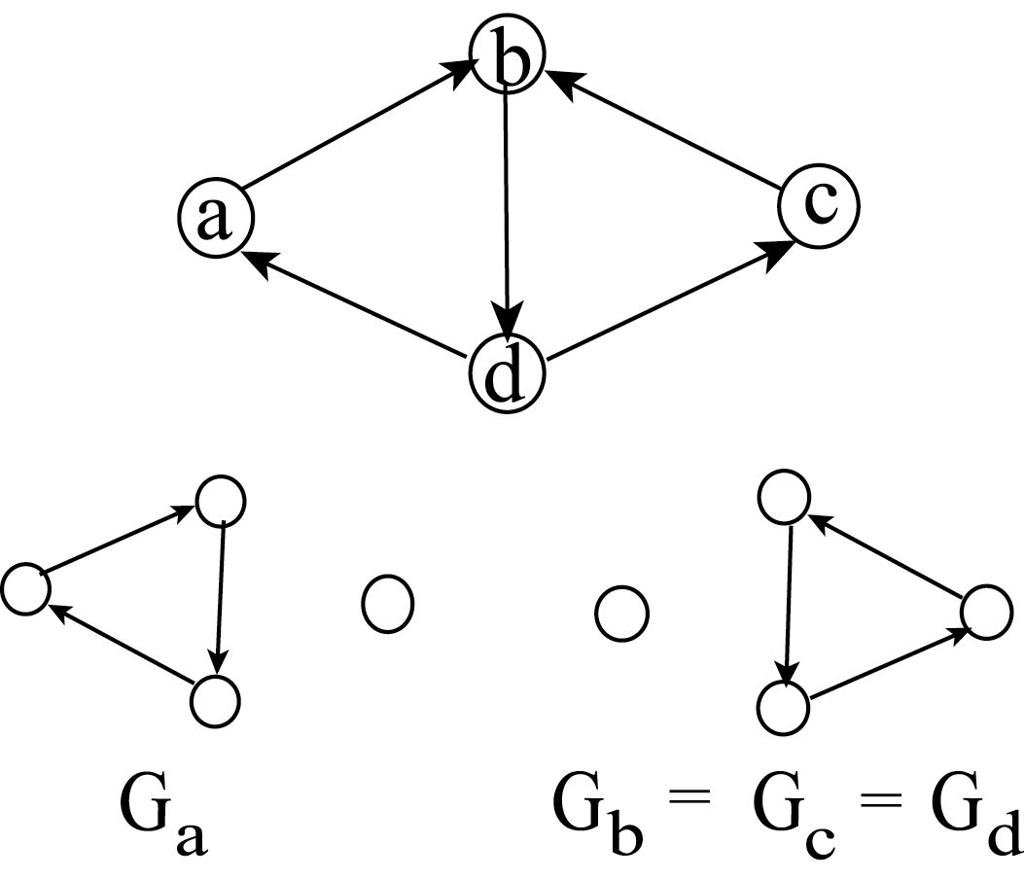
$U_{a}^{+} = \text{ab}, \text{bd}$ $U_{b}^{+} = \text{bd}, \text{dc}$ $U_{c}^{+} = \text{cb}, \text{bd}$
.
$U_{a}^{−} = \text{da}$ $U_{b}^{−} = \text{cb}$ $U_{c}^{−} = \text{dc}$
NB: U_{v} ≠ tree !
Other example: 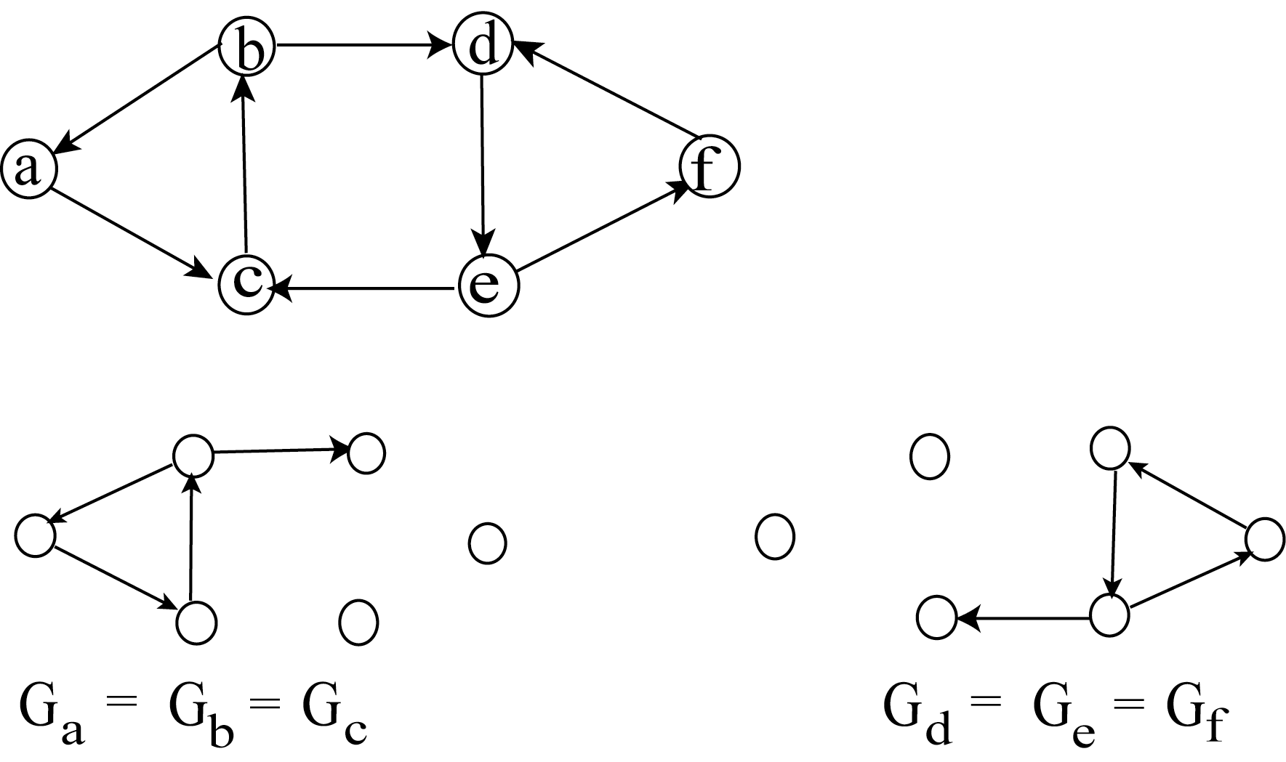
$$\begin{aligned}\left| U_{a} ∪ U_{f} \right| = 8 \\ \end{aligned}$$
s(F,G) ≥ 4
$$U_{b}^{+} = \text{bd},\text{ba}$$
U_{v} ≠ tree ∀ v !
s(F,G) = 4
$$U_{b}^{−} = \text{ac},\text{cb}$$
• • •
$U_{b}^{+} = \text{bd}, \text{ba}$$U_{b}^{−} = \text{ac}, \text{cb}$
$$U_{b}^{+} = \text{bd}, \text{ba}$$

¿ ∃ solution F such that in-tree(v) = Ø ∀ v ?
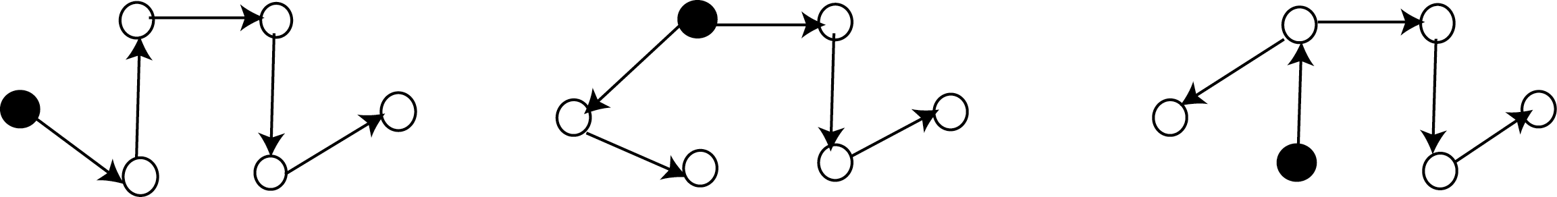
$U_{a} = U_{a}^{+}$ $U_{b} = U_{b}^{+}$ $U_{c} = U_{c}^{+}$

|U_{v}| = |V| - 1 → s(F,G) = |V| - 1 = 5 here !
U_{v} is a tree ∀ v !
¿ ∃ solution F such that s(F,G) = 4
and $U_{v }= U_{v}^{+} ∪ U_{v}^{−}$ (out-tree (v) $∪$ in-tree(v)) ?
NO :
¿ ∃ solution F such that s(F,G) = 4
and U_{v} = tree ∀ v ?
... NO
Problem: min s(F,G)
?
F : U_{v} = tree ∀ v
min s(F,G)
?
F : $U_{v }= U_{v}^{+} ∪ U_{v}^{−}$∀ v

Proposition: (Capkun, Buttyan, Hubaux)
In G = (V,U) strongly connected every
solution F = {G_{v} | v ε V} with
performance p(F,G) = 1, use u_{F,G}(v) = u_{o} ∀ v
and |V_{v}| = n_{o} ∀ v satisfies
$\left| V_{v }\right| ≥ \sqrt{ \left| V \right|} − 1$ s(F,G) ≥ $\sqrt{ \left| V \right|} − 2$
Sketch of pf: Take w ε V : ∀ z : w ⇝ z
z ε V: w ⇝ z
S₁ =
$U_{z}^{−}$
z ε V: ∃ z* w ⇝ z * ⇝ z
S₂ =
$U_{w}^{+}$ $U_{z}^{−}$
z ε V: w ⇝ z
S₃ =
$U_{w}^{+}$
z ε S₁ S₂ S₃
$$\left| V \right| − 1 = \left| S_{1} ∪ S_{2} ∪ S_{3} \right| ≤ \left| S_{1} \right| + \left| S_{2} \right| + \left| S_{3} \right|$$
$n_{o} + \left| V\left(G_{w}\right) \right| u_{F,G} (z) + n_{o} = n_{o}^{2} + 2 n_{o}$
$n_{o} = \left| V_{v }\right| ≥ \sqrt{ \left| V \right|} − 1$
Q.E.D.
Complete graphs K_{n}

- one arc between any two nodes
- G strongly connected

For G = K_{n} ∃ solution F
with performance p(G,F) = 1
and s(F,G) ≤ 1 + ⎡n/2⎤

K_{n} strongly connected ↔ ∃ Hamiltonian cycle
C on nodes 0,1,2,…,n-1
(all numbers modulo n)

case: n even
i
i,j
“opposite nodes”

[i,j], [i+1, j+1]
consecutive edges
between
opposite nodes
i+1
j + 1 = $i + \frac{n}{2} + 1$

$j = i + \frac{n}{2}$

NB: ∃ pair of consecutive edges
[i, j], [i+1, j+1] such that
(i, j), (j+1, i+1) ε U
or (j, i), (i+1, j+1) ε U

i i
i+1
j+1
i+1
j+1
j j
G_{k} G_{k}

i + l ≤ k ≤ j + 1 j + 2 ≤ k ≤ i

$\left| U_{k }\right| = n/2 + 1$ ∀ k
s(F,G) = n/2 + 1
p(F,G) = 1

case: n odd:
G' partial graph formed by
arcs between i, i + ⎣n/2⎦
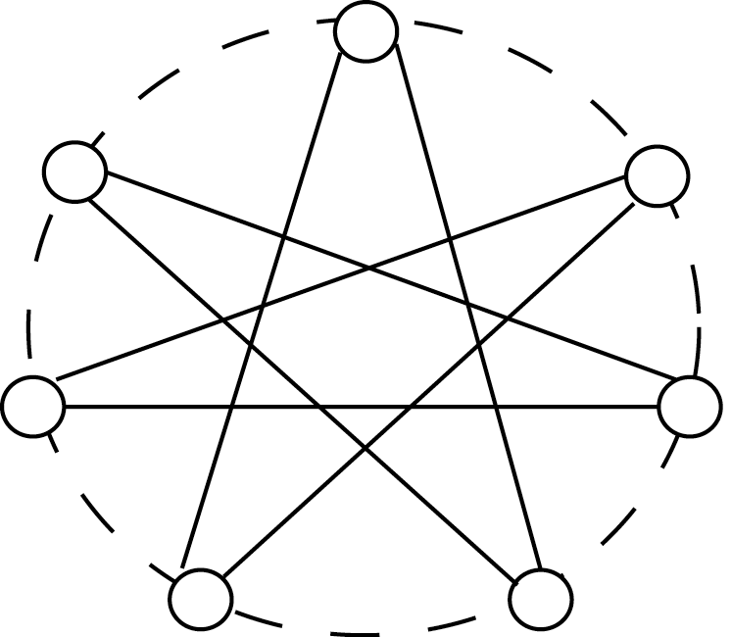
n = 7

degrees = 2

–
i
$i + \left\lfloor n/2 \right\rfloor$

G' contains an odd cycle C
On C ∃ v with
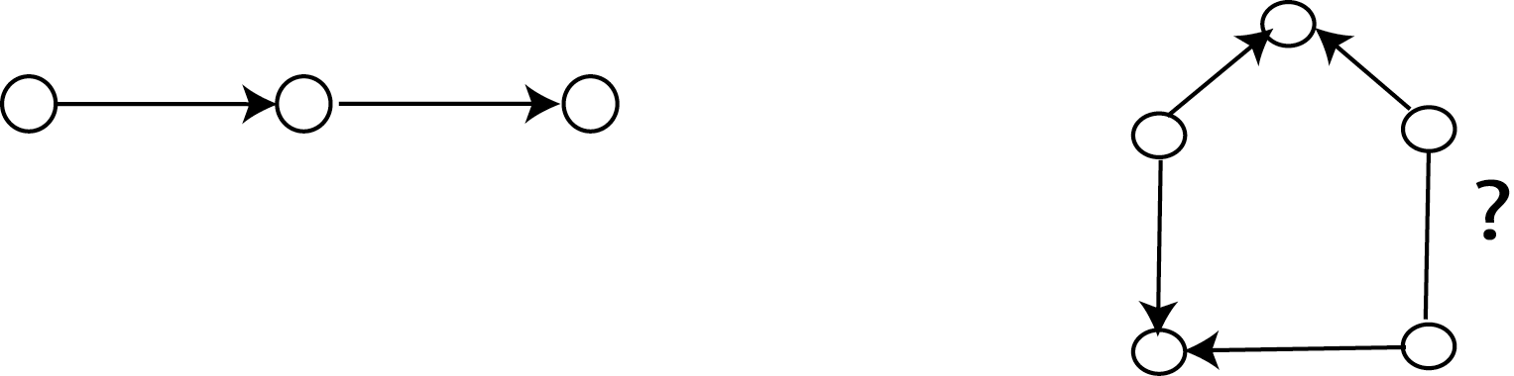
v
i

i + ⎣n/2⎦
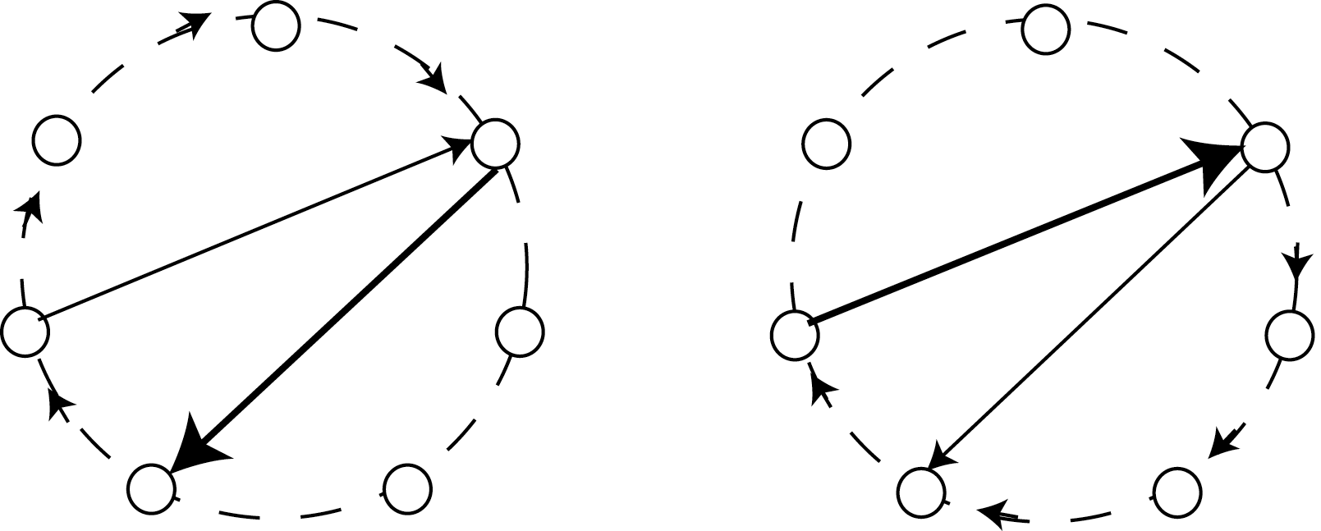
i
i
i + $\left\lfloor \frac{n}{2 }\right\rfloor$ i + $\left\lfloor \frac{n}{2 }\right\rfloor$
G_{k} G_{k}
i + $\left\lfloor \frac{n}{2 }\right\rfloor$ ≤ k ≤ i i + 1 ≤ k ≤ i + $\left\lfloor \frac{n}{2 }\right\rfloor$− 1

|U_{k}| = 1 + $\left\lceil \frac{n}{2 } \right\rceil$
s(F,G) = 1 + $\left\lceil n/2 \right\rceil$
p(F,G) = 1

so s(F,G) ≤ 1 + $\left\lceil n/2 \right\rceil$
in all cases

Q.E.D.

For G = K_{n} there is no solution
F with s(F,G) = 2 and p(F,G) = 1 (n ≥ 4)

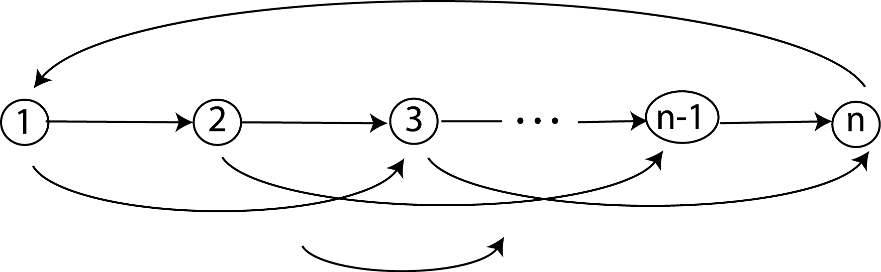
(i,j) i < j 1 ≤ i < j ≤ n
but (n,1)
U_{v} = {(1,v), v,n), (n,1)} v = 2,…,n-1
U_{v} = {(1,2), (2,n), (n,1)} v = 1 and n
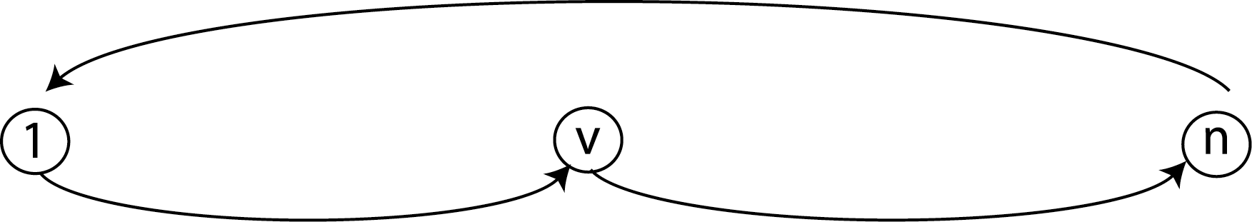
n is a center
For some G = K_{n} there is a solution F with
s(F,G) = 3 and p(F,G) = 1

NB: ALG01 gives a minimumn s(F,G)
for the above complete graphs

Heuristic procedures
ALG01: Find a center x
with max {d(x,v) + d(v,x)} = min !
v ε V

set G_{v} = sp(v,x) sp(x,v)

u(F,G) large for x
p(F,G) = 1

ALGO k among l:
Choose l nodes (l << |V|) $k= \left\lceil \frac{l + 1}{2}\right\rceil$
∀ v ε V set G_{v} = circuit through v and
at least k of the l nodes

∀ v, w V(G_{v}) V(G_{w}) ≠ Ø
→ performance p(F,G) = 1
u(F,G) ≥ $\frac{k}{l} \left| V \right| = \left\lceil \frac{l + 1}{2}\right\rceil \frac{\left| V \right| }{l} ≥ \frac{\left| V \right| }{2}$
NB: $\left\lceil \frac{l + 1}{2}\right\rceil \frac{\left| V \right|}{l} − \left\lceil \frac{l + 3}{2}\right\rceil \frac{\left| V \right|}{\text{l }+2} = \text{.}\text{.}\text{.} = \frac{\left| V \right| }{\text{l }(\text{l }+2)}$
bound decreases by $\frac{\left| V \right| }{3}$when l : 1 → 3
→ Choose l = 3

ALGO 2 among 3:
Choose 3 nodes v₁, v₂, v₃
∀ v ε V, choose 2 nodes x, y in {v₁, v₂, v₃}
G_{v} is sp(v,x) sp(x,y) sp(y,v)
or sp(v,y) sp(y,x) sp(x,v)
(choose minimum length circuit)

ALGO IC (intersecting circuits):
G = (V,U), l given
L = l(l-1)/2
Choose L nodes; call them v₁₂,v₁₃,…,v_{l-1,l}
A_{k} = {v_{ij} | i = k or j = k} for k = 1,…,l
Partition V into l subsets V₁,…,V_{l} of
sizes $\left\lceil \left| V \right| / l\right\rceil \text{or} \left\lfloor \left| V \right| / l\right\rfloor$
for each v ε V do
let k be such that v ε V_{k}
set G_{v} = circuit through v and all
nodes in A_{k}

Example: l = 5 L = 10
v₁₂, v₁₃, v₁₄, v₁₅, v₂₃, v₂₄, v₂₅, v₃₄, v₃₅, v₄₅
A₁ = {v₁₂, v₁₃, v₁₄, v₁₅}
A₂ = {v₁₂, v₂₃, v₂₄, v₂₅}
A₃ = {v₁₃, v₂₃, v₃₄, v₃₅}
A₄ = {v₁₄, v₂₄, v₃₄, v₄₅}
A₅ = {v₁₅, v₂₅, v₃₅, v₄₅}

NB: G_{v} contains node v_{ij} ⇔ v ε V_{i} V_{j}
→ u(F,G) ≥ max$\left( \left| V_{i}\right| + \left| V_{j}\right| \right) ≥ 2 \left\lceil \left| V \right| / l\right\rceil$
i, j

Prop: p(F,G) = 1 for this solution
∀ v, w: ¿ ∃ paths v ⇝w and w ⇝v
in G_{v} G_{w} ?
a) v ε V_{i}, w ε V_{j}: both circuits
contain v_{ij}
b) v, w ε V_{i}: both circuits have
nodes of A_{i} in common
Q.E.D

Experiments with tabu search

min | u(F,G)
s.t | p(F,G) ≥ p_{o}
 | s(F,G) ≤ s_{o}
- Solution space: F: set of graphs G_{v}
(each one is out-tree in-tree)

- neighborhood: addition and removal of arcs
in some subgraphs G_{v}

- Objective function:
f(V) = c₀. u(F,G) +
+ $c_{1} \sum_{v∈V}{{\left(s_{F,G} (v) − s_{o}\right)}^{ +}} + c_{2} {\left(p_{o} − p(F,G) \right)}^{ +}$
- restricted exploration of neighborhood:
3 variants depending upon violation of constraints

- no aspiration function

best results by starting from solution
of ALGO1 and ALGO2among3 (since p(F,G) = 1)

