SD-SQL Server Installation Manual
Soror Sahri
Soror.sahri@dauphine.fr
http://ceria.dauphine.fr/

Table of Contents
1. Introduction 2
2. Package Description 2
2.1 System Requirements 3
2.2 Installation Procedure 3
Acknowledgements 5
References 5

Introduction
SD-SQL Server prototypes a new DBMS architecture. An SD-SQL Server table is automatically and transparently repartitioned when it scales up. With the comfort of a single node SQL Server user, the SD-SQL Server user may manage larger tables or gets a faster response time through the dynamic parallelism, [refs].
From the software architecture point of view, the system is a collection of stored procedure using the services of multiple instances of SQL Server. An SD-SQL Server (scalable distributed) table consists of segments at SD-SQL Server storage nodes supporting dynamic splitting. Splits are triggered by inserts making segments overflowing. Scalable tables are in our system in node databases, constituting further the distributed scalable databases. A scalable database expands transparently on new nodes as much as needed for its largest scalable table (that with most segments).

The management of scalable tables is based on the scalable distributed data structures (SDDS) principles. The user or the application sees a scalable table through a specific view, termed (client) image. In SD-SQL Server, it is a particular updateable distributed partitioned union view. Every image hides the scalable table partitioning and dynamically adjusts to its evolution. A scalable table can present many views, at different nodes, called primary or secondary images. Like in an SDDS, the SD-SQL Server images of the same scalable table may differ among them and from the actual partitioning.
The image adjustment is lazy. It occurs when a query referring to comes in, and finds the image outdated. Our scalable tables and databases make in this way the global database reorganization largely useless. Similarly to B-trees or extensible hash files with respect to the earlier file schemes.
SD-SQL Server runs on a collection of SQL Server linked nodes. For every standard SQL command under SQL Server, there is an SD-SQL Server command for a similar action on scalable tables or views. There are also commands specific to SD-SQL Server image or node management.

Package Description
This download contains the installation manual you are currently reading and the following SQL Server scripts. Save these scripts in C:/script folder at each machine you will install SD-SQL Server. They are used during the installation procedure described below.
- The mdb.sql script. This script generates the Metabase DB. It can be saved only on the first machine used.
- The server.sql script. This script generates an SD-SQL Server server node.
- The client.sql script. This script generates an SD-SQL Server client node.
- The msdb.sql script. This script contains various stored procedures used by other scripts. Installing SD-SQL Server

System Requirements
The system was tested on the following configurations:
- Microsoft SQL Sever 2000/2005 (Developer version)
- Windows 2000 Professional SP3, Windows2003 Server SP2 and Windows XP Professional SP2.
- Local 1Gb/s Ethernet.
- Up to 6 machines.
- At least 768 MB of RAM per machine.

Installation Procedure
- Install SQL Server 2005 on one or more machines connected by a local network. The basic configuration is one instance per machine. Later you can configure each of these instances as an SD-SQL Server client, server or peer (client and server). You can also install several instances per machine. However, such configuration degrades performance. It should be used for didactical or software development purpose only.
As a running example, we consider below the creation of three instances termed Dell1, Dell2 and Dell3 on three different machines with the same names. Naming an instance as its machine is a default option for SQL Server installation.
- Link the instances. For this purpose, execute the sp_addlinkedserver SQL Server stored procedure on each machine. For example, to link Dell2 to Dell1, execute on Dell1 and Dell2 respectively the commands:
sp_addlinkedserver ‘Dell2’ on Dell1 machine
sp_addlinkedserver ‘Dell1’ on Dell2 machine
For more information about sp_addlinkedserver command, see The Microsoft SQL Server Book-on-Line. Notice that for the instances on the same machine slightly different command syntax is needed.
- Create the Meta-database
Execute mdb.sql script, on the SQL Analyzer of the default machine (Dell1 for example). This script will create the Metabase DB with its meta-tables and its stored procedures as shown in Figure 1, below.
The result of the mdb.sql execution is a new Metabase DB with the components below:
- The Nodes and SDB meta-tables with SD role.
- The stored procedures:
  - sd_create_node that allows to create a new SD-SQL Server node.
  - sd_create_node_database that creates a new node database (NDB) for an existing scalable database (SDB).
  - sd_create_scalable_database creates a new scalable database.
  - sd_drop_node removes an existing SD-SQL Server node.
  - sd_drop_node_database removes an existing NDB from a scalable database.
  - sd_drop_scalable_database removes a scalable database.
Details about the commands above are in [1,2,3,4,5].

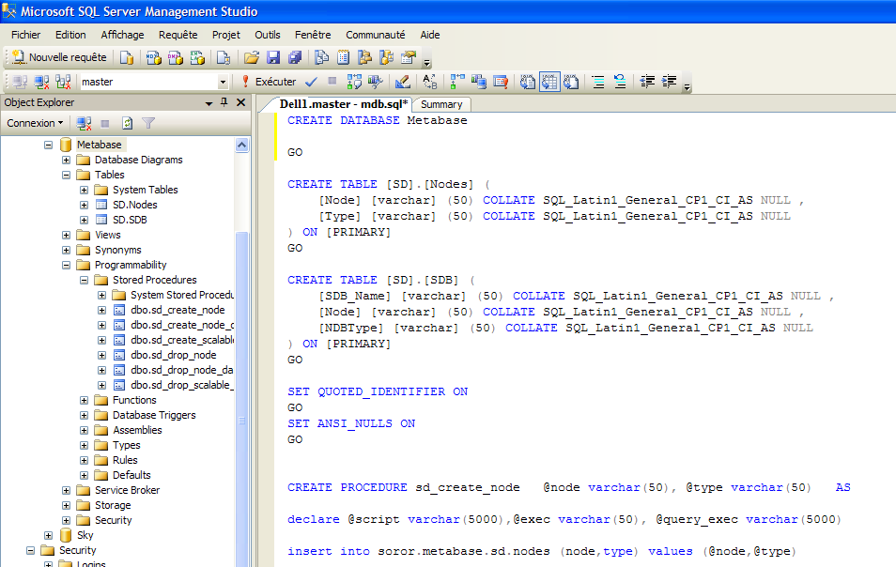
Metabase DB
Figure 1. SQL Analyzer screen of the execution of the mdb.sql script

- Create SD-SQL Server server, client and peer nodes
The SD-SQL Server nodes are the linked SQL Server instances but adapted to SD-SQL Server system. We create them as SD-SQL Server nodes from the Metabase as follows:

  - Create an SD-SQL Server node as a server. For example, we wish to create Dell1 SQL Server instance (on Dell1 machine) as an SD-SQL Server server node. We execute sd_create_node stored procedure as:
sd_create_node 'Dell1', 'server'

  - Create an SD-SQL Server node as a client. We now wish Dell2 instance to be an SD-SQL Server client. We execute sd_create_node stored procedure as below:
sd_create_node 'Dell2', 'client'

  - Create a second SD-SQL Server node as a peer. We finally wish Dell3 instance to be a peer (server and client). We execute sd_create_node stored procedure as follows:
sd_create_node 'Dell3', 'peer'
If one wishes to test splits then several SD-SQL Server server nodes should be created. If one doesn’t need any splits, e.g., because of the use of SD-SQL Server for application testing only, the creation of a single peer node suffices.

- Create and manipulate SD-SQL Server scalable database
Once the node installation procedure is completed, one may start creating the SD-SQL Server scalable databases and populate them with scalable tables. The references [1,3] show the SD-SQL Server commands for this purpose.

Acknowledgements
This work was also supported by Microsoft Research. We are especially grateful for Dr. Jim Gray for all his help since the work on SD-SQL Server started.

References

Notion | Meaning
[1] | Litwin, W., Sahri, S., Schwarz, T. SD-SQL Server: Scalable Distributed Database System. CERIA Research Report 2005-12-13, December 2005.
[2] | Litwin, W., Sahri, S., Schwarz, T. Scalable Command Processing in SD-SQL Server: a Scalable Distributed Database System. 7th Intl. Workshop on Distributed Data and Structures (WDAS-7) Santa Clara, CA, 2006
[3] | Litwin, W., Sahri, S., Schwarz, T. Architecture and Interface of Scalable Distributed Database System SD-SQL Server. The Intl. Ass. of Science and Technology for Development Conf. on Databases and Applications, IASTED-DBA, Insbruck, 2006.
[4] | Litwin, W., Sahri, S., Schwarz, T.: An Overview of a Scalable Distributed Database System SD-SQL Server. In: Flexible and Efficient Information Handling: 23d British National Conference on Databases, BNCOD 23, Belfast, Northern Ireland, UK, July 2006 Proceedings, Bell, D. and Hong, J. (Eds.), Lecture Notes in Computer Science 4942, Springer-Verlag, Berlin, Heidelberg, and New York, 2006, p. 16-35.
[5] | Litwin, W., Sahri, S. & Schwarz, Th. New Features for a Scalable Distributed Databases Management in SD-SQL Server. The 3rd Biennial Conference on Innovative Data Systems Research, CIDR 2007, January 7-10, Asilomar.

